P234.2

#include<iostream>

using namespace std;

class student

{

char name[20];

unsigned int id;

double score;

public:

void input(student &stu)

{

cout<<"name?";

cin>>stu.name;

cout<<"id?";

cin>>stu.id;

cout<<"score?";

cin>>stu.score;

};

void output(student &stu)

{

cout<<"name:"<<stu.name<<"\tid:"<<stu.id<<"\tscore:"<<stu.score<<endl;

};

};

int main()

{

student s;

s.input(s);

s.output(s);

}

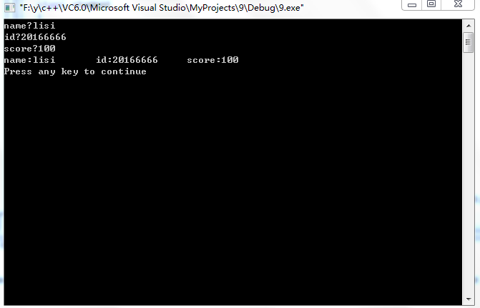

P242.1

#include<iostream>

using namespace std;

class book

{

public:

char \*bookname;

double price;

int number;

void display();

void borrow();

void restore();

};

void book::display()

{

cout<<"书名:"<<bookname<<"\t\t价格:"<<price<<"\t\t当前存书数量:"<<number<<endl;

}

void book::borrow()

{

number=number-1;

cout<<"借阅后的存书数量:"<<number<<endl;

}

void book::restore()

{

number=number+1;

cout<<"归还后的存书数量:"<<number<<endl;

}

int main()

{

cout<<"欢迎来到 一书馆"<<endl;

cout<<endl;

book b1;

char \*p="《魂斗罗：克里斯·保罗传》";

b1.bookname=p;

b1.price=29.9;

b1.number=30;

cout<<"如果你想要查询图书情况，请输入1."<<endl;

cout<<"如果你想要借阅图书，请输入2."<<endl;

cout<<"如果你想要归还图书，请输入3."<<endl;

while(1)

{

int i;

cin>>i;

switch(i)

{

case 1:b1.display();break;

case 2:b1.borrow();break;

case 3:b1.restore();break;

}

}

}

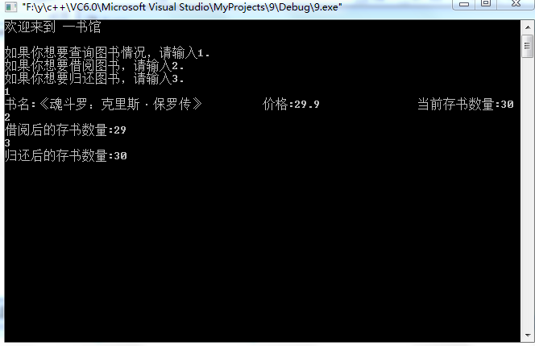

3.

#include<iostream>

using namespace std;

class student

{

public:

void scoretotalcount(double);

static void sum();

static void average();

private:

double score;

static double total;

static int count;

};

double student::total=0;

int student::count=0;

void student::scoretotalcount(double s)

{

score=s;

total=total+score;

count++;

}

void student::sum()

{

cout<<"全班同学的总分为:"<<total<<endl;

}

void student::average()

{

cout<<"平均分为:"<<total/count<<endl;

}

int main()

{

student A;

double s;

int number;

cout<<"请输入学生人数:";

cin>>number;

for(int i=0;i<number;i++)

{

cout<<"请输入第"<<i+1<<"个学生的分数:";

cin>>s;

A.scoretotalcount(s);

}

A.sum();

A.average();

}

